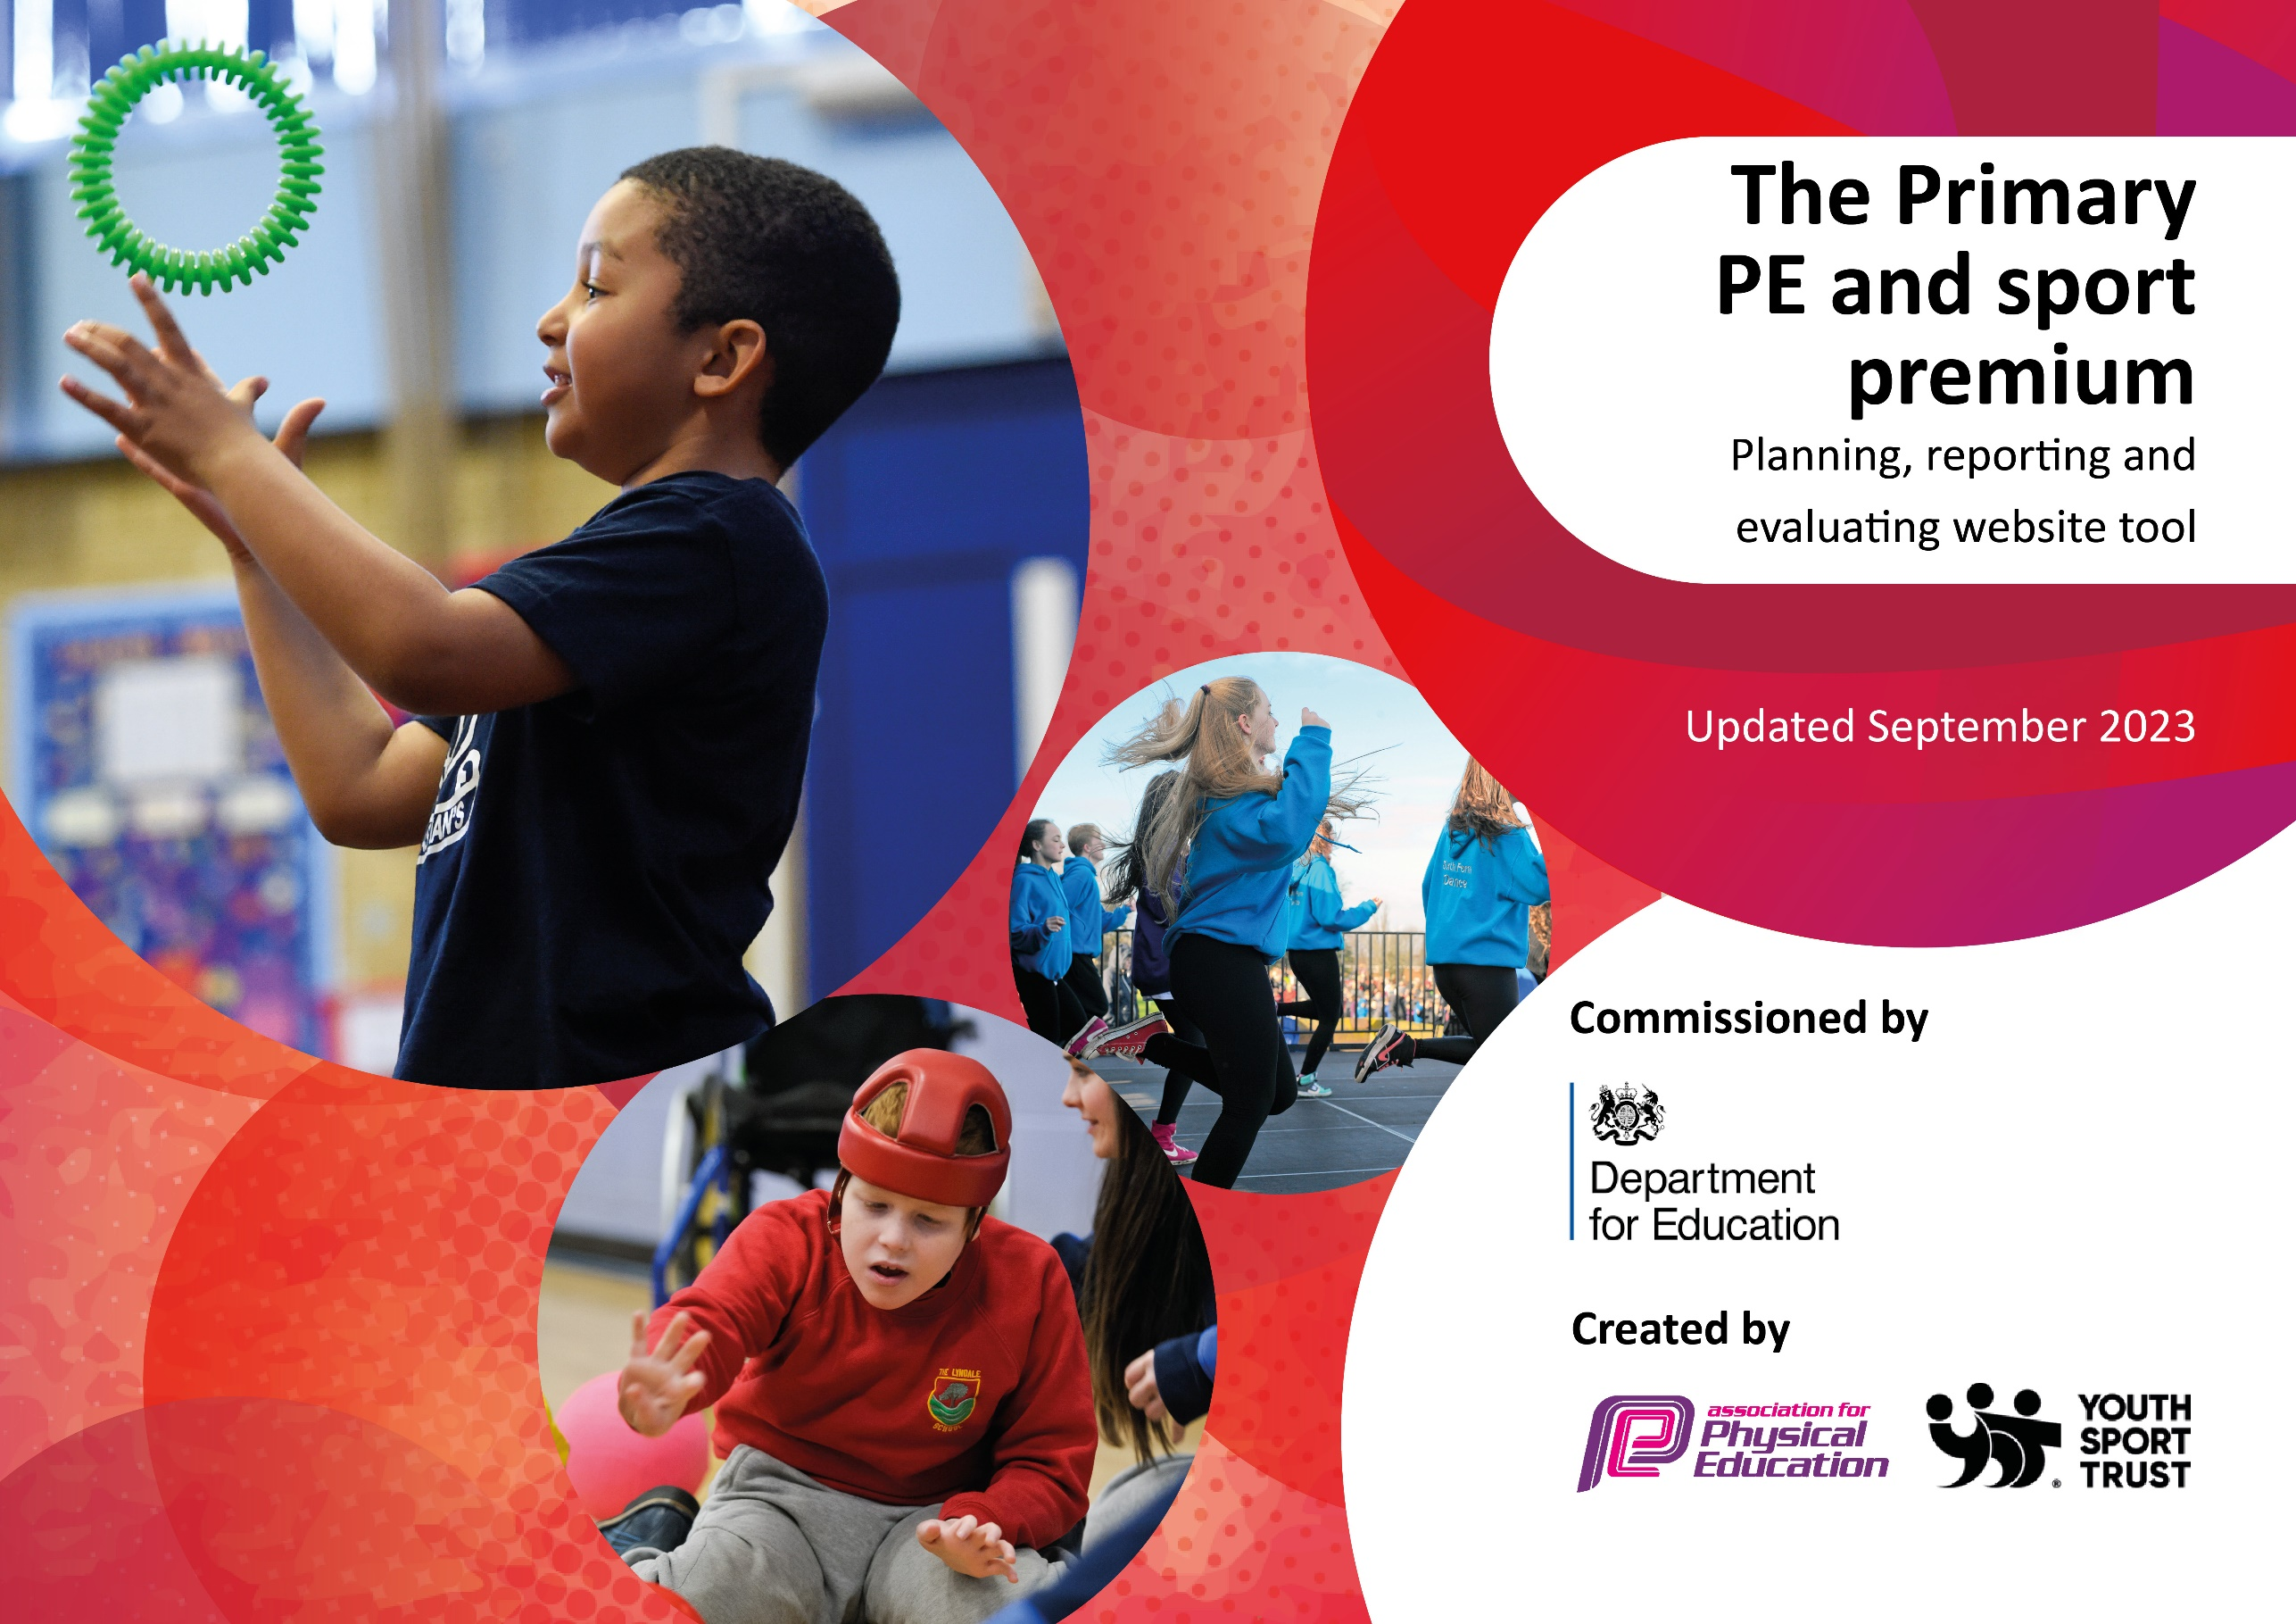

Amington Heath Primary School

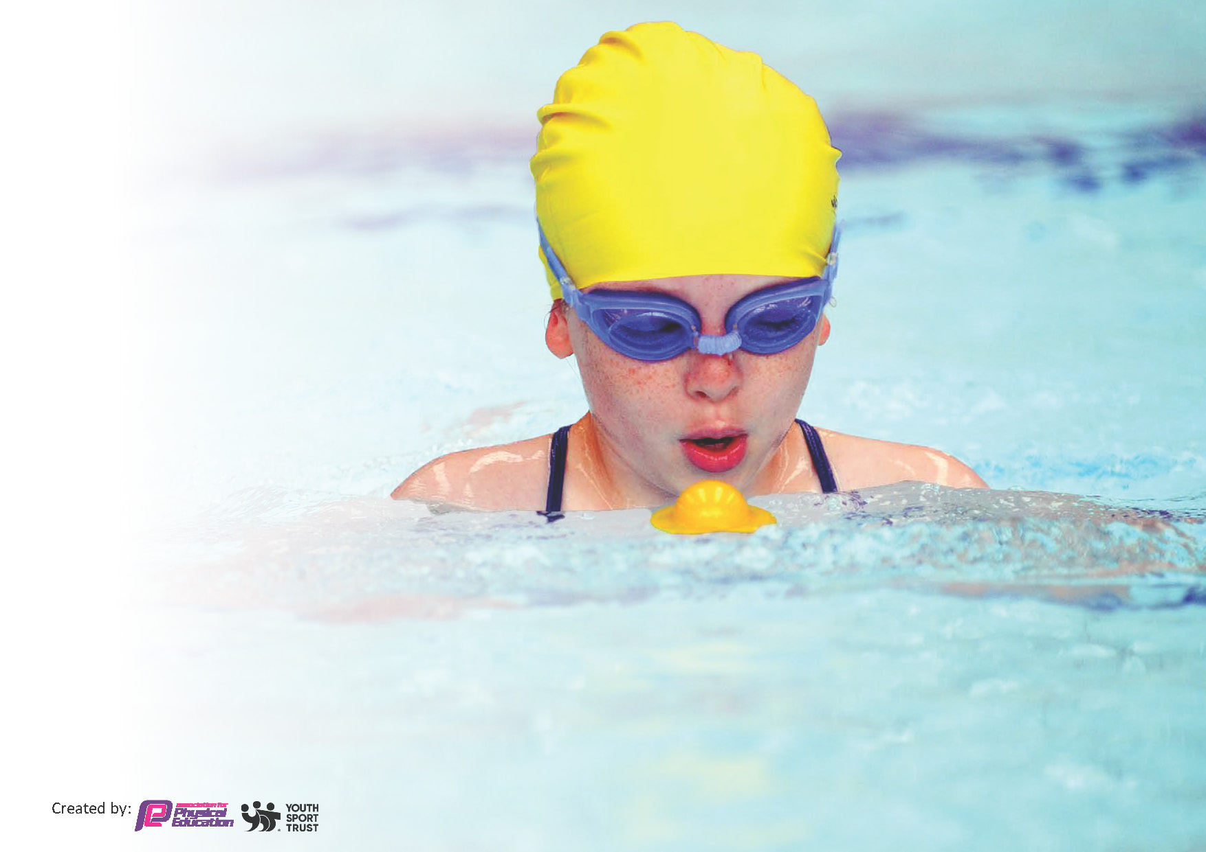
This template can be used for multiple purposes:
by:
- It enables schools to effectively plan their use of the Primary PE and sport premium
- It helps schools to meet the requirements (as set out in guidance) to publish information on their Primary PE and sport premium
- It will be an effective document to support Ofsted inspections enabling schools to evidence progress in Physical Education (PE) and evidence swimming attainment, which forms part of the PE National Curriculum. We would recommend schools consider
the Intent, Implementation and Impact of any spend, as examined within the Education Inspection Framework.

It is important that your grant is used effectively and based on school need.

Schools must use the funding to make additional and sustainable
improvements to the quality of the PE, School Sport and Physical Activity (PESSPA)
they offer. This means that you should use the Primary PE and sport premium to:

- Build capacity and capability within the school to ensure that improvements made now will benefit pupils joining the school in future years
- Develop or add to the PESSPA activities that your school already offers.

The Primary PE and sport premium should not be used to fund capital spend projects; the school’s core budget should fund these. Further detail on capital expenditure can be found in the updated Primary PE and sport premium guidance.

The Primary PE and sport premium guidance, outlines 5 key priorities that funding should be used towards. It is not
necessary that spending has to meet all the key priorities, you should select the priorities that you aim to use any funding towards.

Although completing this template is not a requirement for schools, schools are required to publish details of how they spend this funding. Schools must also outline what the impact this funding has had on pupils’ PE and sport participation and attainment and how any spending will be sustainable in the future. All funding must be spent by 31st July 2024.

The Department for Education has worked closely with the Association for Physical Education (afPE) and the Youth Sport Trust (YST) to develop this template and encourages schools to use it. This template is an effective way of meeting the reporting requirements of the Primary PE and sport premium.
Review of last year’s spend and key achievements (2022/2023)

We recommend you start by reflecting on the impact of current provision and reviewing your previous spend.

Please see review of 2022-23 action plan on school website.

Key priorities and Planning 2023-24
This planning template will allow schools to accurately plan their spending.

Action – what are you planning to do | Who does this action impact? | Key indicator to meet | Impacts and how sustainability will be achieved? | Cost linked to the action
Sports coach to deliver PE curriculum alongside teachers and support staff to upskill and improves subject knowledge | Teachers and support staff – receiving CPD  Pupils - receiving high quality PE lessons | Key indicator 1 – Increased confidence, knowledge and skills of all staff in teaching PE and sport.  Key indicator 3 – The profile of PE and sport is raised across the school as a tool for school improvement  Key indicator 2 – Engagement of all pupils in regular physical activity | Quality of PE teaching will be at least good. Children will enjoy PE lessons and engagement within lessons will be high. | £4032 for sports coach to deliver team teaching one day a week.
Deliver lunchtime clubs to engage prior non attenders | Pupils - all pupils can attend regardless of parent engagement | Key indicator 2 – Engagement of all pupil in regular physical activity  Key indicator 4 – Broader experience of a range of sports and activities offered to all pupils. | All pupils will attend a sports club (either in or after school) particularly those disadvantaged | £1170 – cost of sports coach for 1 hr a week lunchtime clubs (2 x 30 minutes)
Deliver a range of after schools clubs that address a variety of sports and activities | Pupils | Key indicator 2 – Engagement of all pupil in regular physical activity  Key indicator 4 – Broader experience of a range of sports and activities offered to all pupils. | All pupils will attend a sports club in a variety of sport and activities | £1170 - cost of sports coach for 1 hr a week after school club/ (Teachers and support staff also delivering a range of clubs at no additional cost)
Sports coach delivers play time games to increase children participating in physical activity | Pupils | Key indicator 2 – Engagement of all pupil in regular physical activity | Pupils will be have increased physical activity levels | £288 - cost of sports coach for 15 minutes a week play time games
Purchase PE hub to support teachers in planning and delivering PE curriculum | Pupils – teaching and learning is of high quality  Teachers – support teacher subject knowledge | Key indicator 1 – Increased confidence, knowledge and skills of all staff in teaching PE and sport.  Key indicator 4 – Broader experience of a range of sports and activities offered to all pupils. | PE lessons will be at least good with support from PE hub. Subject knowledge will be accurate. | £410 = cost of 12 month subscription
Deliver outdoor learning to all pupils for 1.5hrs a week | Pupils – increased physical activity and promoting health and wellbeing and development of life skills  Staff –support staff receiving CPD through team teaching with lead | Key indicator 2 – Engagement of all pupil in regular physical activity - Raising the profile of health & wellbeing and the development of life skills. | Physical activity increases. Pupils can talk about wellbeing and healthy life styles confidently. | £3389 – cost of outdoor learning lead for 1.5 hrs a week per class + PPA time.
Swimming badges are bought and presented in assemblies | Pupils – strive to achieve badges  Parents – awareness of achievements and successes | Key indicator 5 – Increased participation in competitive sport. | Physical activity increases through swimming.  Pupils will be proud of their achievements and are able to encourage themselves to achieve badges. | £150 – cost of badges
OPAL- increasing physical activity at break time and lunchtime | Pupils - all pupils can engage regardless of parent engagement | Key indicator 2 – Engagement of all pupil in regular physical activity  Key indicator 3 – The profile of PE and sport is raised across the school as a tool for school improvement | Physical activity increases. Pupils can talk about wellbeing and healthy life styles confidently. | £3389 – cost of OPAL lead
New timetabling – 2 hours PE & 2 hours outdoor learning | Pupils – increased physical activity and PE teaching  Staff – CPD through extra PE sessions (team teaching) | Key indicator 1 – Increased confidence, knowledge and skills of all staff in teaching PE and sport.  Key indicator 3 – The profile of PE and sport is raised across the school as a tool for school improvement  Key indicator 2 – Engagement of all pupils in regular physical activity | Pupils are physically active for the required amount of time. | No cost
Patriate in local sports competitions led by sports council by supporting pupils with transport to competitions. | Pupils - engage in competitive sport | Key indicator 5 – Increased participation in competitive sport  Key indicator 4 – Broader experience of a range of sports and activities offered to all pupils. | An increased number of pupils engage in competitive sport | £300 – cost of transport
Set up in inter school house competitions | Pupils - engage in competitive sport | Key indicator 5 – Increased participation in competitive sport  Key indicator 4 – Broader experience of a range of sports and activities offered to all pupils. | An increased number of pupils engage in competitive sport | No cost
Host cluster sports competitions | Pupils - engage in competitive sport  Parents – no transport issues | Key indicator 5 – Increased participation in competitive sport  Key indicator 4 – Broader experience of a range of sports and activities offered to all pupils. | An increased number of pupils engage in competitive sport | No cost
Whole school enrichment activities promote a range of sports and activities | Pupils – engage in new sports and activities  Staff- CPD through team teaching/observing delivery | Key indicator 2 – Engagement of all pupils in regular physical activity  Key indicator 4 – Broader experience of a range of sports and activities offered to all pupils | All children engage in 3 non-curriculum activities over the year. | £1200 – cost on one activity per term (full day)
Purchase PE equipment | Pupils – have equipment needed for each lesson  Staff- have equipment to deliver lessons effectively | Key indicator 1 – Increased confidence, knowledge and skills of all staff in teaching PE and sport.  Key indicator 3 – The profile of PE and sport is raised across the school as a tool for school | PE lessons are appropriately equipped | £1000 – new resources
Ensure all children are able to access residential by providing subsidised places | Pupils – all able to attend residential outdoor activity  Parents – able to send children on residential | Key indicator 4 – Broader experience of a range of sports and activities offered to all pupils  Key indicator 2 – Engagement of all pupils in regular physical activity | The vast majority of children (all those who want to) attend residential outdoor activity trip including those who are disadvantaged. | £500 - subsidy
Provide swimming lessons beyond the curriculum to ensure all non-swimmers are able to strive to meet the EOKS2 outcomes | Pupils – attend swimming lessons until meet EOKS2 outcomes | Key indicator 2 – Engagement of all pupils in regular physical activity  Key indicator 4 – Broader experience of a range of sports and activities offered to all pupils | Increased percentage achieving EOFKS2 outcomes | £400 – contribution towards additional ‘catch-up’ swimming sessions

Key achievements 2023-2024
This template will be completed at the end of the academic year and will showcase the key achievements schools have made with their Primary PE and sport premium spending.

Activity/Action | Impact | Comments
Sports coach to deliver PE curriculum alongside teachers and support staff to upskill and improves subject knowledge. | Staff can see a well-taught PE lesson. More children are engaging due to teachers and support staff being able to encourage more engagement. Staff knowledge is improving.  Active lessons are implemented for each year group taught by the sports coach. | A sports coach will be kept on in September for half a day session, a lunchtime club and an after-school club.
Deliver lunchtime clubs to engage prior non attenders | More children are engaging in physical exercise at lunch time. Structured games engage more children. | Started off the year with having specific target children- this needs to be more consistent next year. To further target those non-attenders, be consistent with choosing the children (that want to attend) to encourage them to attend.
Deliver a range of after schools clubs that address a variety of sports and activities | Children are exposed to different sports that they may not necessarily engage with in lessons. | A timetable will be created for this next year.
Sports coach delivers play time games to increase children participating in physical activity | More children are engaging in physical exercise at break and lunch time. | A timetable will be created for this next year.
Purchase PE hub to support teachers in planning and delivering PE curriculum | Clear, consistent planning and delivery. Clear learning intentions for staff to follow. Decreases planning time for staff.  Learning walks show this is being used effectively and lessons are active from the beginning. Subject knowledge is accurate. | PE hub is still effective for staff to teach good quality PE lessons, this is evident during learning walks.
Deliver outdoor learning to all pupils for 1.5hrs a week | Every class has their entitled hours. Effective use of this has more children engaged.
Swimming badges are bought and presented in assemblies | Children can celebrate their achievement with the school. Children can feel proud and take pride in their achievements. Showcases what can be achieved in the future for other year groups too.
OPAL- increasing physical activity at break time and lunchtime | OPAL received the platinum award which showcases a clear engagement and an increase in physical activity at break time and lunchtime.
New timetabling – 2 hours PE & 2 hours outdoor learning | Every class has their entitled hours. Effective use of this has more children engaged.  Children can experience more of their topic for the term as they have more time to practice the skills being taught. | Year 5 and 6 need to be using their PE slots effectively, to ensure the 2 hours of PE is consistent throughout the school.
Patriate in local sports competitions led by sports council by supporting pupils with transport to competitions. | More participation in cross country. Year 4,5 and 6 participated. Attended a KS2 athletics competition. | KS2 athletics competition was extremely successful. Children and parents gave positive feedback from this and we came 4th place out of 7 schools.
Set up in inter school house competitions | 2 interhouse competitions were completed. The children enjoyed these and good feedback was given. Children were given the opportunity to engage in a competition. | A timetable will be created for this next year.
Host cluster sports competitions | Not completed.
Whole school enrichment activities promote a range of sports and activities | Non-contact boxing through Progressive Sports and breakdancing enrichment day.  Children also experienced a dance workshop which was enjoyed by many. Children engaged well and liked joining in with sports not in our specific curriculum.
Purchase PE equipment | PE equipment order completed to ensure that all lessons are well equipped. PE cupboard was tidied and re-organised to make sure that the equipment is accessible.
Ensure all children are able to access residential by providing subsidised places | All children were given the opportunity to attend the residential trip in year 5 and 6 to Whitemoor Lakes.
Provide swimming lessons beyond the curriculum to ensure all non-swimmers are able to strive to meet the EOKS2 outcomes | Swimming lessons every Tuesday morning. Year 5 and 6 were given equal opportunities to learn to swim confidently, safely and competently. Water safety was also completed. | Year 5 were given a booster lesson to ensure they had a clear opportunity to meet the KS2 learning outcomes.

Swimming Data
Meeting National Curriculum requirements for swimming and water safety.
Priority should always be given to ensuring that pupils can perform safe self-rescue even if they do not fully meet the first two requirements of the National Curriculum programme of study

Question | Stats: | Further context  Relative to local challenges
What percentage of your current Year 6 cohort can swim competently, confidently and proficiently over a distance of at least 25 metres? | 91.3% | Lower due to some children not attending due to absence and medical needs.
What percentage of your current Year 6 cohort can use a range of strokes effectively [for example, front crawl, backstroke, and breaststroke]? | 74% | Some children struggled to use a range of strokes effectively but 100% of children could swim using front crawl.

What percentage of your current Year 6 cohort are able to perform safe self-rescue in different water-based situations? | 91.3% | 2 children were absent, 1 due to medical needs.
If your schools swimming data is below national expectation, you can choose to use the Primary PE and sport premium to provide additional top-up sessions for those pupils that did not meet National Curriculum  requirements after the completion of core lessons. Have you done this? | Yes/No
Have you provided CPD to improve the knowledge and confidence of staff to be able to teach swimming and water safety? | Yes/No | External provider teaches the swimming lessons.

Signed off by:

Head Teacher: | Charlotte Davies
Subject Leader or the individual responsible for the Primary PE and sport premium: | Eden Cleaver, class teacher and Physical Education Lead.
Governor: | Matthew Wilkinson (Governor responsible for grants)
Date: | 18/7/24

